**Blog about windows and document object**

**Window:**

* **The window is the first thing that gets loaded into the browser**
* **This window object has the majority of the properties like length, innerheight, name, open, close, moveTo, resize etc.,**
* **Window is the global object**

**Image of the window without document object**

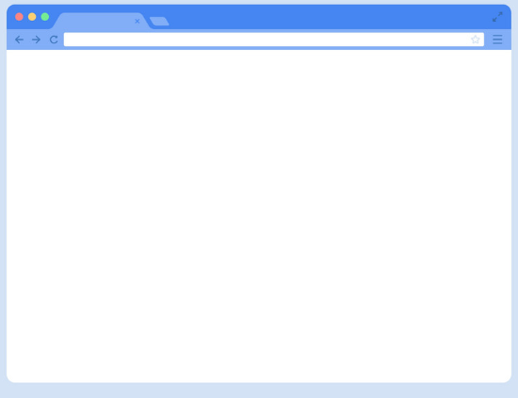

**The document:**

* **The document object is html,aspx,php or other document that will be loaded into the browser**
* **The document actually gets loaded inside the window object and window object and has properties available to it like title,URL,cookies and all properties related to DOM**

**The image of document object loaded into the window object**

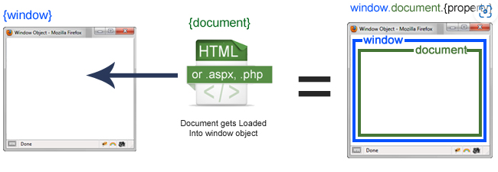

DETAILED EXPLANATION

The JavaScript provides essential tools for manipulating and interacting with web pages. Two core objects, window and document, play pivotal roles in this environment. Let's delve into what each of these objects represents and their significance in web development.

**Window Object**

The window object serves as the top-level container for everything within the browser's JavaScript environment. Here are key aspects of the window object:

1. **Global Scope**: Variables and functions declared globally become properties and methods of the window object. This makes them accessible throughout your script.
2. **Properties and Methods**: window offers a wealth of properties and methods that facilitate various tasks such as:
   * Controlling the browser window's size and position (innerWidth, innerHeight, outerWidth, outerHeight).
   * Managing navigation (location, history, navigator).
   * Setting timers (setTimeout, setInterval) and handling events (addEventListener).
3. **Child Objects**: Within window, you'll find related objects like:
   * window.document: Represents the DOM (Document Object Model) of the currently loaded HTML document.
   * window.localStorage: Allows storage of key-value pairs persistently within the browser.
   * Other specialized interfaces for interacting with the browser environment.

**Document Object:**

The document object represents the structure of the current HTML document displayed in the browser. Key features include:

1. **DOM Manipulation**: Provides methods to access and modify elements within the HTML document, facilitating dynamic updates and interactivity.
2. **Event Handling**: Enables attachment of event listeners to respond to user actions (e.g., clicks, keystrokes) or document state changes (e.g., document load, resize).
3. **Navigation**: Offers methods to navigate and manipulate the document structure, such as accessing links (getElementsByTagName, getElementsByClassName) and forms (forms collection)
4. **Content Creation**: Allows creation of new elements (createElement), appending nodes (appendChild), and modifying element attributes and styles dynamically.

**Difference:**

|  |  |  |
| --- | --- | --- |
| **S.no** | **Document object** | **Window object** |
| 1 | It represents the html document or any other doument | It represents a browser window |
| 2 | It is loaded inside the window | It is the very first object loaded inside the browser |
| 3 | It is object of window property | It is the object of browser |
| 4 | We can access the document from a window using the  window.document | We can access the window from the window only .  i.e window.window |
| 5 | The document is part of (browser and window object model) | Window is browser object model |
| 6 | Syntax:  document.propertyname | Syntax:  window.propertyname |
| 7 |  | Example:  window.open  window.close  window.moveTo |

Practical Application

* **Updating Page Content**: Use document.getElementById or document.querySelector to fetch elements and modify their content or appearance.
* **Handling User Interactions**: Attach event listeners to elements using addEventListener to respond to user interactions like clicks or form submissions.
* **Manipulating DOM Structure**: Dynamically add, remove, or modify elements within the document based on user input or application logic.

Conclusion

Mastering the window and document objects empowers developers to create dynamic and responsive web applications. Understanding their properties, methods, and interplay is essential for effective DOM manipulation, event handling, and overall web development proficiency. By leveraging these objects, developers can enhance user experiences and build robust, interactive web solutions.

In summary, the window and document objects form the foundation of client-side JavaScript programming, enabling developers to harness the full potential of web browsers for creating modern web experiences.